SAMPLE MST PAPER for PLC V1.5

1. Which is NOT true about the PLC scan cycle
2. It consists of the time taken to read the inputs status
3. It consists of the time taken to update the output status
4. It consists of the time taken to convert global memory into IO
5. It consists of the time take to execute the program
6. What is a relay?
7. A mechanical switch
8. A programmable PLC
9. An electromechanical switch
10. A Pneumatic switch
11. What is NOT a benefit of PLC?
12. Reduced space required compare to relay logic
13. Ease of implementation and making changes to logic
14. Reduced wiring
15. Reduced reliability
16. Ladder diagram below shows two on-delay timers. Which one of the following statements is correct based on this ladder diagram?



T#5s

T#3s

1. Actuator is activated 3s after the Sensor is activated. Actuator remains activated for 5s
2. Actuator is activated 3s after the Sensor is activated. Actuator remains activated for 2s
3. Actuator is activated 3s after the Sensor is activated. Actuator remains activated for 3s
4. Actuator is activated 2s after the Sensor is activated. Actuator remains activated for 2s
5. What is TRUE about the relay below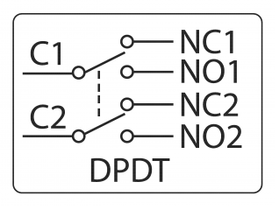
6. DPDT. When energized, C1 is electrically connected to C2
7. DPDT. When energized, C1 is electrically connected to NO1
8. 4PDT. When energized, C2 is electrically connected to NC2
9. 4PDT. When energized, C2 is electrically connected to NC1
10. Refer to program. When the Sensor is activated for 7s, the _______?



Lamp

TON

T#3s

1. Lamp will turn ON immediately when Sensor is activated. It stays on for 7 seconds.
2. Lamp will turn ON immediately when Sensor is activated. It stays on for 10 seconds.
3. Lamp will be turn ON 3 seconds after Sensor is activated
4. Lamp will be turn ON 3 seconds after Sensor is de-activated
5. For CTD counter, when LD=1 and PV=2, the values of QD and CV will be _____
6. QD=1, CV=unknown
7. QD=1, CV=2
8. QD=0, CV=2
9. QD=0, CV=unknown
10. Refer to the timing diagram. What function block is needed to program this?



INPUT_X

RESETB

OUTPUT_Y

1. Up Counter
2. Greater than
3. Off Delay Timer
4. Set Reset Flip Flop
5. What is NOT true about the following instruction?

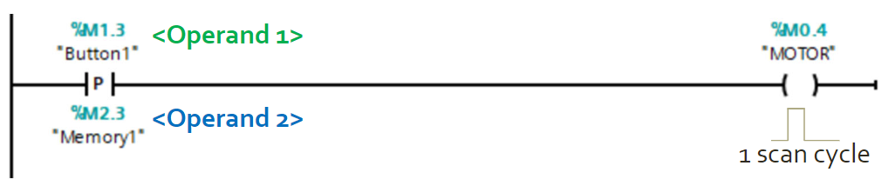

Bit1

Bit2

State5

1. Instruction detects change of "0" to "1" for Bit1
2. The current signal state of Bit1 is compared with its signal state in the previous scan
3. State5 will turn on for 1 scan cycle when Button1 is on
4. Bit1 is called the edge memory bit and shall be defined as %M
5. Decimal is a numbering system with ________________
6. Base 2
7. Base 8
8. Base 10
9. Base 16
10. Convert F in Hexadecimal to Binary. Select the correct answer.
11. 111
12. 1011
13. 1111
14. 0001 0101
15. PLC and computer systems store information in memory locations or registers as a Word. How many bits and byte are there in a word?
16. 4 bits, 1 byte
17. 8 bits, 2 bytes
18. 8 bits, 1 byte
19. 16bits, 2 bytes
20. What function block does the following timing diagram represent?

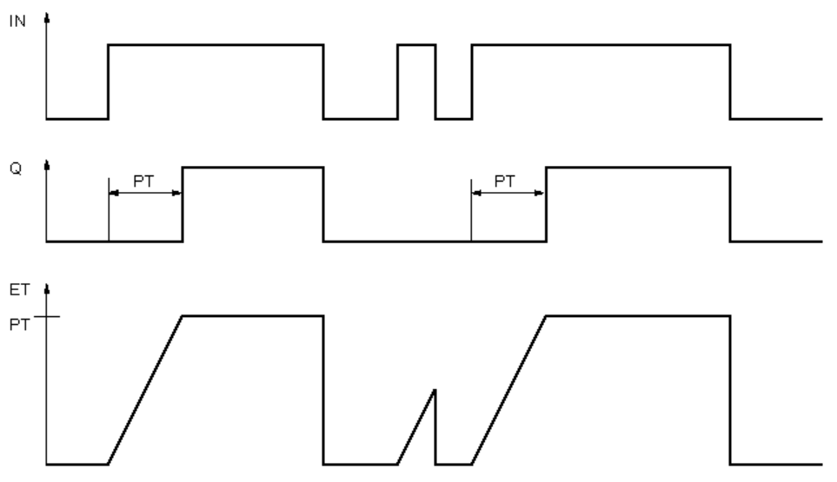

1. Off Delay Timer
2. Down Counter
3. On Delay Timer
4. Up Counter
5. Which of the following IEC 61131 programming language is non graphical?
6. Ladder Diagram
7. Instruction List
8. Sequential Function Chart
9. C++
10. 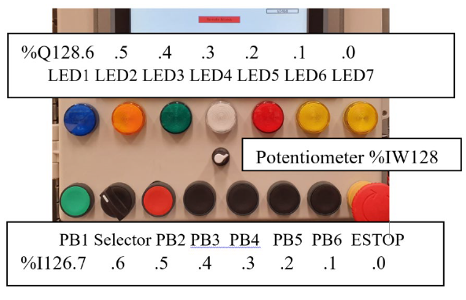From the PLC, you read the byte %Q128 has hexadecimal value 0x02. Select the correct status:
11. LED2 is on, the rest are off
12. LED6 and LED7 are ON. The rest are off
13. LED6 is ON. The rest are off
14. LED3 is ON. The rest are off

1. Which of the follow address represents 32bit data?
2. %I33.0
3. %MB3
4. %QD2
5. %Q3.2
6. The following shows _______________

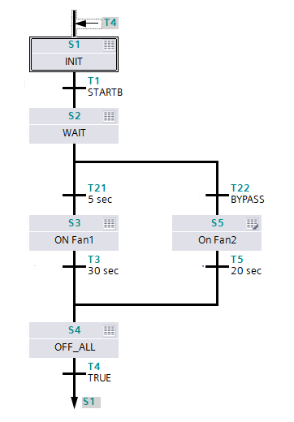

1. FBD programming with simultaneous branch
2. SFC programming with simultaneous branch
3. FBD programming with alternative branch
4. SFC programming with alternative branch
5. If the following is a PLC program, what type of Stop Button should be connected to the PLC?

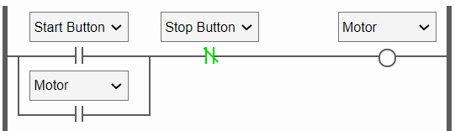

1. Normally Open type
2. Normally Close type
3. Latched type
4. Toggle type
5. What is TRUE regarding Down Counters?
6. Output bit CU will activate when CV is less than or equal to 0
7. Output bit CD will activate when CV is less than or equal to PV
8. Output bit QD will activate when CV is less than or equal to 0
9. Output bit QD will activate when CV is less than or equal to PV
10. What is the difference between INT and UINT?
11. INT can represent negative value while UINT cannot.
12. INT is a complete memory block while UINT is partial memory block
13. INT takes up more bit that UINT
14. INT is an older version of UINT

ANSWER KEY SECTION A

ANSWER KEY

|  |  |
| --- | --- |
| 1 | C |
| 2 | C |
| 3 | D |
| 4 | B |
| 5 | B |
| 6 | C |
| 7 | C |
| 8 | A |
| 9 | D |
| 10 | C |
| 11 | C |
| 12 | D |
| 13 | C |
| 14 | B |
| 15 | C |
| 16 | C |
| 17 | **D** |
| 18 | A |
| 19 | C |
| 20 | A |